- Staff Directory needs to be updated:

Walsh, Tameka Administrative Assistant Email 617-394-2325
Lariviere, Ernest Superintendent of Water Email 617-394-2270
Rauseo, Kim Administrative Assistant Email 617-394-2327
Renzulli, Ralph Assistant Water Superintendent Email 617-394-2270

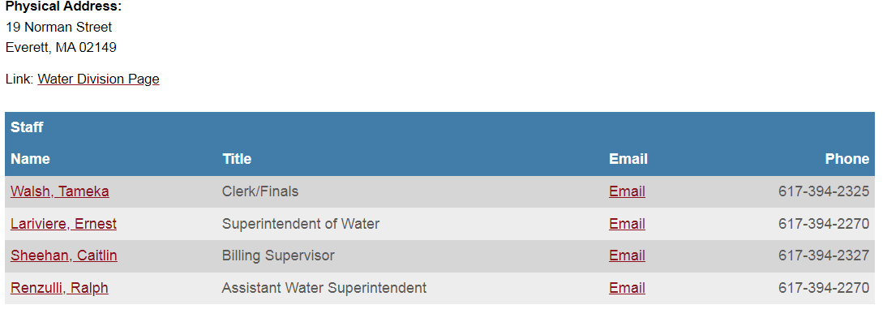

- Back flow application to be added under related documents (attached)

- Remove document cross connection program

- FY 22 water/sewer rates need to be posted and all hyperlinks updated. There is a hyper link on this page http://cityofeverett.com/Faq.aspx?QID=119 (attached)

- Remove Monthly Billing Letter

- Update the Consumer Confidence Report (attached)

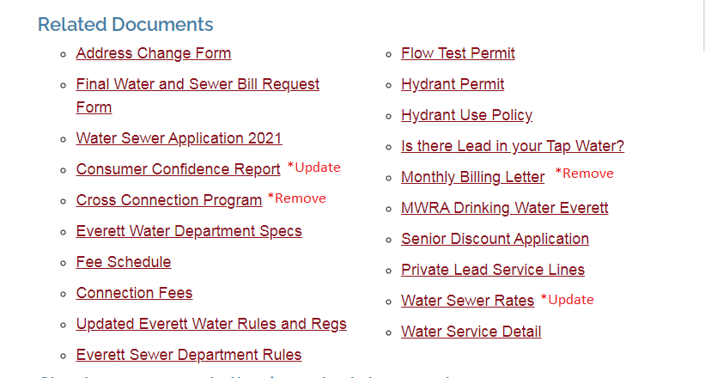

- Add a link to WaterSmart. Can this pic be made into a hyperlink?
(www.everett.watersmart.com)

- Hyperlink needs to be updated on this page
http://cityofeverett.com/Faq.aspx?TID=26,
The Final Bill Request Form (it was updated on the related document section)

