**  
AGENDA PACKET**

**Committee on Ways & Means  
Monday, April 28, 2025 5:30 PM  
  
EVERETT CITY HALL, 484 BROADWAY, CITY COUNCIL CHAMBERS, 3RD FLOOR**everett, MA 02149

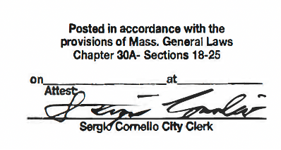

10:53 AM

4/24/2025

4/28/2025

**  
AGENDA**

**Committee on Ways & Means  
Monday, April 28, 2025 5:30 PM  
  
EVERETT CITY HALL, 484 BROADWAY, CITY COUNCIL CHAMBERS, 3RD FLOOR**everett, MA 02149

|  |  |  |
| --- | --- | --- |
| |  | | --- | | **ROLL CALL** | |  | |

|  |  |  |
| --- | --- | --- |
| |  | | --- | | **PLEDGE OF ALLEGIANCE** | |  | |

|  |  |  |  |  |  |  |  |  |
| --- | --- | --- | --- | --- | --- | --- | --- | --- |
| |  | | --- | | **UNFINISHED BUSINESS** | | |  |  | | --- | --- | | **1.** | C0027-25  Resolution/s/ Councilor Anthony DiPierro  A resolution requesting the CFO to appear before the Committee on Ways & Means to discuss the Hero Act; specifically the increased local flexibility for Veteran Tax Exemptions. |  |  |  | | --- | --- | | **2.** | C0135-25  Order/s/ Councilor Stephanie Martins, as President  An order requesting approval to appropriate $6,672 from General Fund Budgetary Fund Balance (Free Cash) to pay prior year legal bills per the attached list |  |  |  | | --- | --- | | **3.** | C0136-25  Order/s/ Councilor Stephanie Martins, as President  An order requesting approval to appropriate $82,000 from General Fund Budgetary Fund Balance (Free Cash) to the Human Resources Local 25 benefits account. This appropriation is necessary to cover additional costs related to the three local 25 unions | | |

|  |  |  |
| --- | --- | --- |
| |  | | --- | | **ADJOURNMENT** | |  | |

[www.cityofeverett.com](http://www.cityofeverett.com )  
(All agendas and reports can be obtained on City of Everett Website)   
  
Respectfully submitted:

## **Michael J. Mangan**

Legislative Aide  
Everett City Council Office