AGENDA

**License Meeting**

**Monday, April 28, 2025**

**Everett City Hall, Room 27 @ 6:30 PM**

**484 Broadway**

**Everett, MA 02149**

Order of Business:

1. Call to Order
2. Roll Call
3. Approval of Minutes from March 17, 2025
4. New Business:
5. An application for the approval of a Transfer of License from Liu Holdings d/b/a Sei Bar, 916 Broadway, Everett to ZL Cajun Inc. d/b/a Cajun Corner Seafood Boil, 916 Broadway, Everett.
6. An application from Woody’s Parkway Pub, 1812 Revere Beach Pkwy, for a Change of Manager, Change of Offices and a Transfer of Stock/New Stockholder
7. An application for a Transfer of License, Alteration of Premise from MCRC Inc d/b/a Champions Café, 234 Main St to El Nopal Bar and Grill Inc d/b/a Champions Cafe
8. Abbondanza Restaurant, 195 Main St., requesting to extend hours to 1:00 AM because their 6-month probation period for new owners has ended.
9. Short Path Distillery, 71 Kelvin St, approval for their 4th Annual Summer Sipper on Saturday, June 7, 2025 from 11AM to 8PM.
10. Varun Punj, speak to Board in regards to a proposal for a restaurant at 355 Ferry St
11. Councilor Katy Rogers, would like to speak with the License Board in regards to the banning of the sale of nips in all the package stores.
12. Reserved for items not reasonably anticipated by the Chair
13. 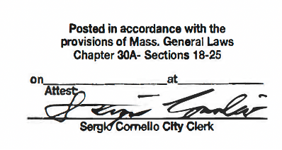Adjournment

9:24 AM

4/24/2025

**Signed: ___________________________________**

**Phil Antonelli**

**Chairman**

**Open Meeting Law Certification:**